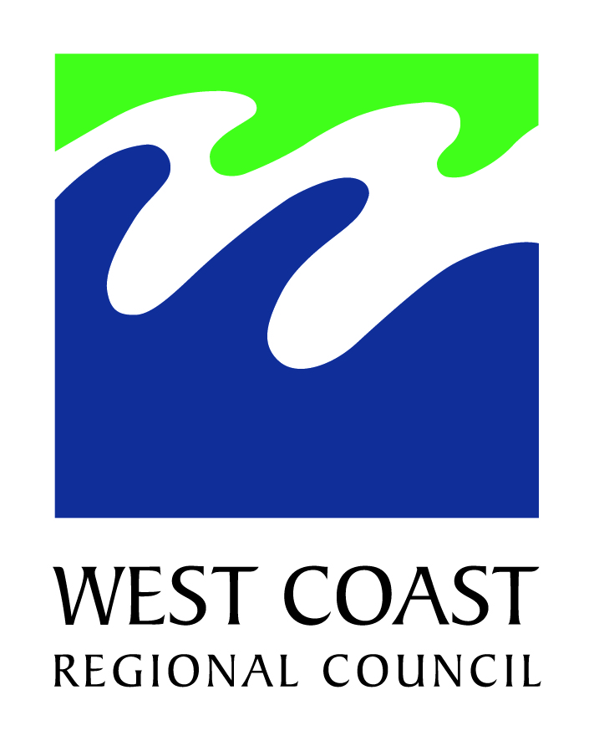



**PUBLIC COPY**

**Meeting of The Franz Josef Joint Committee**

**Rating District**

***(Te Huinga Tu)***

**Thursday, 29th August 2024**

**6:00PM**

**97 Cron Street, Medical Centre**

**FRANZ JOSEF**

**The membership of the committee is:**

* Councillor Andy Campbell, West Coast Regional Council - Westland Constituency (Chair of the Joint Committee)
* Councillor Peter Haddock, West Coast Regional Council - Westland Constituency
* Councillor Brett Cummings, West Coast Regional Council - Grey Constituency (appointed as third
* WCRC member)
* Mayor Helen Lash (Deputy Chair of the Joint Committee)
* Deputy Mayor Ashley Cassin, Westland District Council
* Councillor Brian Manera, Westland District Council
* Paul Madgwick, Te Rūnanga o Makaawhio
* Owen Kilgour, Department of Conservation
* James Caygill, New Zealand Transport Agency
* Dale Straight, South side community representative
* Graham Berry, South side community representative
* Jeremy Williams, South side community representative
* Kelley Molloy, South side community representative
* Ian Hartshorne, North side community representative
* Grant Gibb, North side community representative
* Logan Skinner, North side community representative
* Kim Smith, North side community representative

**Franz Josef Joint Committee Rating District Meeting**

***(Te Huinga Tu)***

**AGENDA**

**(*Rarangi Take)***

|  |  |
| --- | --- |
|  | **Pg No.** |
| 1. **Welcome *(Haere mai)*** |  |
| 1. **Apologies *(Ngā Pa Pouri)*** |  |
| 1. **Declarations of Interest** | **1-4** |
| 1. **Public Forum, Petitions and Deputations *(He Huinga tuku korero)*** |  |
| 1. **Confirmation of Minutes *(Whakau korero)*** |  |
| * 1. Amended Minutes of the Franz Josef Joint Committee Rating District Meeting 18th December 2023   2. Minutes of the Franz Josef Joint Committee Rating District   Meeting 6th May 2024  **Matters Arising** | **5-12**  **13-21** |
| 1. **Actions List**    1. Actions List | **22-27** |
|  |  |
| 1. **Reports**    1. Franz Josef Rating District Joint Committee Agreement Updated May 2024    2. Legal Opinion on Credit Liability to Franz Josef Rating District Ratepayers & Rock Stockpile Management    3. Rock Stockpile at Franz Josef    4. Franz Josef Joint Committee Proposed Debt Merge    5. Franz Josef Joint Committee Rating District-Proposed Merging of Rating Methods    6. River Training Downstream of Waiho Loop    7. Insurance Costs Clarification    8. Canavan’s Knob Rock Quarry Potential    9. Avulsion Development    10. Before the Deluge 2 – Update on Waiho South Bank Capital works Proposal *(late paper to be presented to the Committee prior to the meeting)* | **28-36**  **37-40**  **41-42**  **43-47**  **48-52**  **53-61**  **62**  **63-64**  **65-66** |
|  |  |
| 1. **General Business** 2. **Public Forum, Petitions and Deputations** 3. **Next Meeting**   **D. Lew**  **Chief Executive** |  |
|  |  |
|  |  |
|  |  |
|  |  |
|  |  |
|  |  |
|  |  |

**Purpose of Local Government**

The reports contained in this agenda address the requirements of the Local Government Act 2002 in relation to decision making. Unless otherwise stated, the recommended option promotes the social, economic, environmental, and cultural well-being of communities in the present and for the future.

**Health and Safety Emergency Procedure**

In the event of an emergency, please exit through the emergency door in the medical centre.

If you require assistance to exit, please see a staff member. Once you exit the building make your way to the assembly point at the grassed area at the front of the building. Staff will guide you to an alternative route if necessary.