To: Franz Josef Joint Committee

From: Chris Heath, WCRC Quarry Manager

Date: 9th August 2024

Re: Canavan’s Knob - Rock Quarry Potential

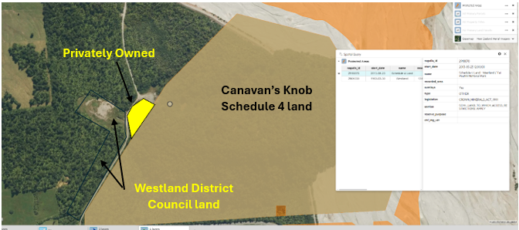

A small triangle on the southern end of Canavan’s Knob is privately owned. This is an area of 1Ha. The Quarry Manager has located a geological report for Canavan’s Knob (completed in 1970) that indicates the rock on the southern end is adequate for Armour grade protection rock.

(See extracts of 1970 report below)

The Quarry Manager has been in contact with the landowner to open discussions about this location as a potential quarry. The landowner has responded, a site visit was carried out on the 13th of August, and the landowner is currently considering the possibility.