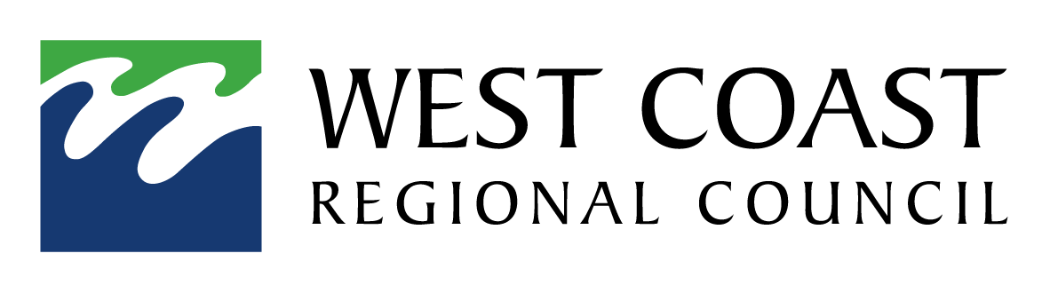

To: Franz Josef Joint Committee
From: Darryl Lew
Date: 02 August 2024
Re: Clarification of 24/25 Insurance costs

- The Franz Josef Joint Committee were provided with the 2024/2025 proposed rate strike information at the meeting held in May 2024
- The rate strike information was missing information detailing insurance costs
- The joint committee endorsed the proposed rates strike at the May meeting to include insurance costs of $13,906.00
- The West Coast regional can confirm the assets are insured and the 2024/2025 rates are proposed to be struck to include insurance at $13,906.00

