|  |  |
| --- | --- |
|  | **Landowner Proposal for River Training Downstream of Waiho Loop** |
| **Author** | Kent Jacobsen, Area Engineer  John Ellis, Engineering Officer |
| **Authorizer** | Tom Hopkins, Group Manager Catchment Management |
| **Public Excluded** | No |
|  |  |

**Report Purpose**

The purpose of this report is to bring to the Franz Josef Rating District Joint Committee a request for assistance from rating district members on the south side of the Waiho River. The request is for assistance in training the Waiho River away from properties on the true left bank where erosion and damage to property and assets has actively been occurring.

**Report Summary**

Riverbank erosion on the true left bank of the Waiho River below the Waiho Loop has been actively occurring, with several residences and farming infrastructure that could become compromised.

The proposal is to carry out river training using a bulldozer to attempt to constrain the river’s primary flows to the north side (true right bank) of the waterway, away from the farms on the south side (true left bank). The work is estimated to cost up to $126,000 (excluding resource consent costs and staff time) and is proposed to be funded from Franz Josef Rating District reserves.

This is presented as a one-off cost and it should be noted that further expenditure will definitely be required to continue to attempt to constrain the river’s primary flows to the north side downstream of the Waiho Loop.

**Recommendations**

***It is recommended that the Joint Committee resolve to:***

1. *Receive the report*
2. *Note that the proposed work does not constitute Emergency Works, that resource consent will be required to enable the work, and that Council will apply for and (subject to approval by the consenting authority), obtain the consent*
3. *Note that the physical work is required to be procured in accordance with Council’s Procurement Policy*
4. *The Joint Committee advise staff whether or not they authorise the use of the Rating District’s reserves to fund the proposed work, noting that considerable ongoing expenditure will more than likely be required to maintain a preferential channel on the true right (north side) of the river*

**Issues and Discussion**

### **Background**

Below the Waiho Loop there are three key farms managed by Pete Dennehy, Todd Brunning and Neil Friendrup.

These farms receive flood protection from the defences on the true left bank of the Waiho River. Should a flood breach these defences, the flood water will pursue a path to the ocean that could go through any or all of their farms.

Below the Waiho Loop on the true left bank the Milton and Others stopbank abruptly finishes, with no scheme assets downstream of this reach. This year alone there has been ongoing erosion of the bank at the edge of these farms.

Under the 10-yr strategy released in 2023 the approach to managing flood hazard on the south bank of the Waiho is to ‘hold the line’ while a masterplan is developed for future use of the area.

The three landowners on the true left bank downstream of Milton’s and others stopbank have requested Council consider their proposed flood mitigation measures in an effort to reduce the risk of further damage to their properties during future flood events in the Waiho River.

The flood mitigation measure being proposed is to use a bulldozer to form a preferential channel braid (‘river training’) along the north bank of the Waiho, away from the properties in question.

### **Current situation**

At time of the most recent inspection (10th July 2024) the main braid of the Waiho was flowing into and through the Tatare Gap. From then on downstream the dominant channel tends to follow the true right bank against the hill until well below the Brunning property.

This means that most of the left bank frontages do not have water flowing against them which also clearly exposed the large areas of river gravels and active bank erosion present with subsequent pasture loss and destruction of floodplain fencing. The land involved is without question floodplain and is consequently low lying when compared to the actual river channel and is also bereft of any woody tree plantings which could help reduce overland flow velocities and provide some protection to fences etc.

Following the inspection of 10th July a conversation with the farmers involved ensued with the following points discussed:

* That the costs involved in constructing effective Fit for Purpose protection for the individual properties would be prohibitively expensive was acknowledged by all parties,
* The only short-term alternative was to encourage the river to remain flowing along the northern right bank,
* The only viable way to achieve this goal was by the carefully planned use of a large bulldozer,
* As it happens there is a large bulldozer (90 ton) available in the immediate vicinity

However, the inspection of the Milton and Others stopbank shows that any of the proposed river training work downstream would be rather pointless unless some additional improvements are undertaken on and immediately downstream of this structure. This work is as follows:

* Repair the lower downstream section of the Milton stopbank,
* Improve the formation of the Franz Dairies owned bund immediately downstream of the Milton stopbank,
* Carry out channel capacity improvement immediately downstream of the Franz Dairies owned bund to encourage continued main flow migration toward the northern true right bank.

Should the proposal outlined in this report be implemented, river training will need to be repeated on an as and when required basis. The duration and frequency is difficult to ascertain, but will definitely be required given the shift in the Interdecadal Pacific Oscillation to favour increased westerly storms and the known issue of aggradation with the Waiho River.

Further to this, the river training concept is based on there being a preferential channel on the true right bank of the river below the Waiho Loop (as is the case at present). However, following the July 2024 LiDAR survey of the Waiho, aggradation of the riverbed below the Tartare Gap has been detected. This aggradation (which will ultimately migrate downstream to fill the preferential channel on the true right increases the risk that the proposed river training works will be compromised and likely even rendered infeasible.

The proposal to carry out the river training work should be subject to the following:

* That this work is primarily to contribute to implementing the 10-year plan to ‘hold the line’ while a masterplan for the area is developed.
* That provision is made to fund ongoing maintenance of the re-trained river.
* Resource consent will be required and the funding, time and staff to obtain this has not yet been identified.

As per the Terms of Reference dated updated March 2024, *“The WCRC is empowered by Section 126 of the Soil and Conservation and Rivers Control Act 1941 to take such steps as are necessary for the prevention of damage by floods”.*

Clause 23 states: *“Without limiting the ability of the Joint Committee to recommend the most appropriate arrangements for works and funding, in relation to the Franz Josef flood defence assets, the WCRC shall be responsible for all works and funding relating to:*

* *The maintenance and repair of the structural integrity of the flood defence assets managed under WCRC Asset Management Plans;*
* *The provision of flood warning advice to WDC for the Waiho River; and*
* *Ownership of the flood defence assets as identified in WCRC Asset Management Plans.*

Furthermore, clause 24 states: *“The WCRC has constituted a “Franz Josef Rating District” and reserves the right to raise such funds as it may need to carry out its function under clause 23 above from this source”.*

### **Options Analysis**

There are three options:

1. Do nothing; Leave the river to its own agenda with the three lower farms being subject to ongoing threat from the Waiho river below the Milton and Others stopbank.
2. Do as proposed; The river training works may provide some relief to the three lower farms while we ‘hold the line’ in accordance with the 10-yr Waiho Strategy
3. Alternative option; Neither of the above. This could range in scope from installing stopbanks, rocking the river-training works or introducing other engineering controls. Other controls such as stopbanking are less favourable, possibly not being practically viable and likely prohibitively expensive.Adequate protection of the exposed banks would require literally tens of thousands of tons of rock which apart from the cost is actually not immediately available for placement in any case.

### **Costs and Benefits**

The cost of the work was proposed by the applicants at $120,000. This was on the basis that there is a current contractor with plant available on-site. Mobilisation of plant (bulldozer) from e.g. Greymouth is roughly estimated at an additional cost of $15,000 each way.

Staff estimate the cost of the proposed work to be as follows:

|  |  |  |  |  |
| --- | --- | --- | --- | --- |
|  | Item | Quantity | Rate | Cost |
| 1/ | Channel improvement/enhancement RB northern bank, 90t Bulldozer | 150hrs | $600 | $90,000 |
| 2/ | Repair lower Milton and Others stopbank, improve Franz Dairies bund and channels D/S, 90t Bulldozer | 60hrs | $600 | $36,000 |
|  | | | | $126,000 |

At various stages during the inspection and ongoing conversation it was pointed out to the participants that the proposed flood mitigation methodology is very susceptible to damage from the river during high flows and they agreed any work in the river was very dependent upon subsequent weather events. With this in mind it was recommended that rather than expend all available resources at once it would make more sense to carry out the more obvious channel reconfiguration as estimated in Item 1 above to say an 80- or 90-hours machine time limit for the bulldozer and hold the balance in credit until required. A smaller machine should be adequate to carry out any follow-up work.

The improvement work proposed at Miltons in Item 2 above should still proceed as described above, noting that some or all of this work could be included in scope for the second stage of the Franz Josef Flood Protection Scheme Upgrade, the offer to the community for this project having been formally announced by Central Government on Monday 12th August.

**Considerations**

### **Implications/Risks**

Policy:

* Risk of interpretation to ensure this workstream does not set a precedent for other river training works on waterways in the catchment.

Cost:

* Risk of expending funds to carry out the river training work when even a moderate flood could result in the river migrating back toward the true left bank. A significant forward program of channel training to keep the river on the true right will likely be required, along with associated ongoing expenditure

### **Significance and Engagement Policy Assessment**

There are no issues within this report which trigger matters in this policy.

### **Tangata whenua views**

Tangata whenua are present on the Franz Josef Rating District Joint Committee and consideration of this paper this will provide the platform for their input, together with any cultural opportunity through the resource consenting phase (if required).

### **Views of affected parties**

Both WCRC’s Area Engineer Kent Jacobsen and Engineering Officer John Ellis have spoken with each of the lower three landowners and visited the locations where erosion is occurring. The landowners have all stated they pay into the special rating district for protection upstream of their farmland. They feel is it important to try to obtain funding for protection alongside their properties from rating district reserves.

### **Financial implications**

This proposal is considered a maintenance activity and attracts operational expenditure as opposed to capital. As there is no other operational fund source available, funding for the proposal must come from rating district reserves.

*Current budget*

Council is currently working through reconciling its accounts for the 2023/24 financial year ahead of producing annual works and financial reports for the next round of rating district meetings (scheduled for the coming spring months).

Based on the information available at present, the best estimate of the rating district reserve balance at the start of the 2024/25 financial year is $34,400.00. However, it should be noted that if items of work carried out during 2023/24 and considered to be capital expenditure are transferred from the rating district’s maintenance account to the rating district’s loan account, the rating district’s maintenance reserve balance at the start of the 2024/25 financial year would be approximately $175,000.

The annual budget for maintenance proposed (but yet to be struck) for the 2024/25 year is $106,800 (excluding Engineer Cost Recovery and Insurance).

Therefore, total funds available to the rating district for maintenance for 2024/25 will be approximately:

* $141,200 if items of work carried out during 2023/24 and classified as capital expenditure ARE NOT transferred to the rating district’s loan account
* $281,800 if items of work carried out during 2023/24 and classified as capital expenditure ARE transferred to the rating district’s loan account

*Future implications*

Funding any further work required to continue to train the river away from south side farms

### **Legal implications**

No specific legal advice has been sought.

### **Attachments**

Attachment 1 of 3: Photo of erosion

Attachment 2 of 3: Photo of erosion

Attachment 3 of 3: Photo of erosion

Map of training works based on 20th February 2024 communications

Figure 1Natural bank erosion beside Todd Brunners property

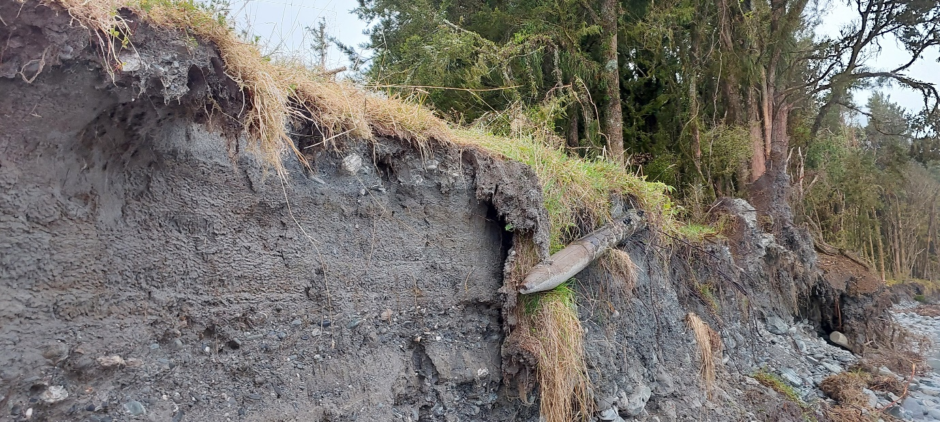

Figure 2: Bank erosion including compromised fencing

Figure 3: A new, recently formed channel through farmland resulting in scour and erosion. Fencing remnants covered in debris.

Figure 4: Map of proposed river training from 20th February 2024.